Lecturer’s name: | Date:
Course: ELA7 | Duration 45- 60 min
Unit 1: Literacy Essentials | TEKS:  7.10B.ii: developing an engaging idea reflecting depth of thought with specific facts, details, and examples;
Topic: Elaborate to develop voice in writing and in life
Lesson objectives:
- SWBAT elaborate in writing using specific facts, details, and examples
- SWBAT develop their writer’s voice using a variety of author’s craft strategies
Essential Questions:
- Why is it important to develop your ‘voice’ in writing and in life?
- In writing and in life, why is it important to support your ideas with facts, details, and examples?
LYS Methodology
Be (Character/Values/Principles) - Cultural- Identity
Know (What resources are available to the student/ How can they use them) - Spiritual- Inspiration
Do (Execute with Excellence) - Vocational- Discipline
Resources (Include Technology):
Individual Copies:
- This I Believe: Be Cool To the Pizza Dude https://www.npr.org/2005/05/16/4651531/be-cool-to-the-pizza-dude
- Student created OUTLINE and FIRST DRAFT answering What do I want? Why do I want it? How will I get it (ELA7_U1_L12_Make a plan for writing and your future AND ELA7_U1_L13_Introductions and organization in writing and life)
- Student Rubric (G7 STAAR Rubric) https://tea.texas.gov/sites/default/files/Rubric-G07-WrtgExpository.pdf
- Docs Handout: https://docs.google.com/document/d/1wlSqAbZKdJLeWNFoB8Yo5qLyXX9ZsuNSjk99WU-obzE/edit
Instructional Input - Asynchronous
AS: Anticipatory Set (Introduction)
- Read and analyze:
  - This I Believe: Be Cool To the Pizza Dude. As students read, they should use the Graphic Organizer (included in Synchronous section) to notice the Author’s Voice and Craft by selecting at least 4 phrases or complete sentences that stand out. Guide students to focus on sentences that express a specific feeling or strongly reveal what the author is like.
- Reflect in Writing:
  - What do you think this author is like? What makes you think this?
  - Does this seem like someone you might enjoy hanging out with or find things in common with? Why or why not?
- Watch and Learn: Learning Rocks! Writing Trait, Voice: https://www.youtube.com/watch?v=dKeq5ICmVHo
  - What is Voice? After watching, students should be prepared to discuss what “Voice” is and how it is created in writing.
  - Pass out the Author’s Craft cards and let students review the examples. Explain that these strategies are just some of the ways that Authors create voice in their writing.
- Set a Purpose:
  - Today, we will elaborate on our first draft in order to ensure this essay uses each of your personal “voice”. In each paragraph (including the introduction and conclusion), you will add at least one of the examples below. It is important that you use strategies that feel like the way you would talk or express yourself. It is okay to use a strategy/ technique more than once, but since this is a short essay, you should try at least three different strategies in your writing.
M: Modeling (I do)
- Analyze the exemplar:
  - Use the author’s craft cards provided to revisit “This I Believe: Be Cool to the Pizza Dude”. Identify at least two of the craft moves the author used in this essay. (Teacher should provide one completed example for reference)
    - Note for students that these are examples that they can use to assist in their own writing.
- Introduce the “Author’s Purpose and Voice” Planning chart and identify the Audience, Message, and Purpose for this essay. (in Synchronous section)
- Provide a model selecting an Author’s Craft strategy, choosing your paragraph, analyzing the context (what is already written) and either adding a new sentence or modifying one already written to better express your ‘voice’ as a writer. Ask students: What strategy did I use? What information do I include? How does this make you feel as a reader? What does it make you think about me as a writer?
GP: Guided Practice (We do)
- Students use the planning chart, author’s craft cards and their first draft to create strong sentences they can add to their writing.
Instructional Input - Synchronous
AS: Anticipatory Set (Introduction)
- Read and analyze:
  - This I Believe: Be Cool To the Pizza Dude. As students read, they should use the Graphic Organizer to notice the Author’s Voice and Craft by selecting at least 4 phrases or complete sentences that stand out. Guide students to focus on sentences that express a specific feeling or strongly reveal what the author is like.
Phrase/ Sentence that stands out | Why I like it | How it makes me feel | Author’s Craft
- Share out. Ask:
  - What stood out to you? Why?
  - What do you think this author is like? What makes you think this?
  - Does this seem like someone you might enjoy hanging out with or find things in common with? Why or why not?
- Watch and Learn: Learning Rocks! Writing Trait, Voice: https://www.youtube.com/watch?v=dKeq5ICmVHo
  - What is Voice? After watching, students should be prepared to discuss what “Voice” is and how it is created in writing.
  - Pass out the Author’s Craft cards and let students review the examples. Explain that these strategies are just some of the ways that Author’s create voice in their writing.
- Set a Purpose:
  - Today, we will elaborate on our first draft in order to ensure this essay uses each of your personal “voice”. In each paragraph (including the introduction and conclusion), you will add at least one of the examples below. It is important that you use strategies that feel like the way you would talk or express yourself. It is okay to use a strategy/ technique more than once, but since this is a short essay, you should try at least three different strategies in your writing.
M: Modeling (I do)
- Analyze the exemplar:
  - Use the author’s craft cards provided to revisit “This I Believe: Be Cool to the Pizza Dude”. Work as a class, individually, or in small groups to identify at least two of the craft moves the author used in this essay.
    - Review as a class.
    - Note for students that these are examples that they can use to assist in their own writing.
- Introduce the “Author’s Purpose and Voice” Planning chart and work as a class to identify the Audience, Message, and Purpose for this essay.
- Model selecting an Author’s Craft strategy, choosing your paragraph, analyzing the context (what is already written) and either adding a new sentence or modifying one already written to better express your ‘voice’ as a writer. Ask students: What strategy did I use? What information do I include? How does this make you feel as a reader? What does it make you think about me as a writer?

Author’s Purpose and Voice Planning Chart
Audience (who will read this?): | Message (what am I trying to express?) | Purpose (why did I write this?)  - Persuade  - Inform  - Entertain  about/ because…
Author’s Craft Strategy: | Paragraph/ Idea | Author’s Craft/ Voice Sentence to Add:

GP: Guided Practice (We do)
- Students use the planning chart, author’s craft cards and their first draft to create strong sentences they can add to their writing.
Independent Practice/ Homework
- Rewrite your first draft:
  - Add your new ‘Voice’ sentences.
  - Check for correct capitalization and punctuation.
  - Use a formal font (Times New Roman, Calibri, or Arial) and size (10-12 pt)
Lesson Close

What is the answer to the essential question, and why does it matter to me in terms of:
- Cultural- Identity
- Spiritual- Inspiration
- Vocational- Discipline

Developing your identity is hard. As you grow up, you must think about what is important to you, who you trust and why, what you want for your future, but also where you come from and let all of these things help shape the way you define yourself and present yourself to others. In writing, your voice is very much like your identity. Just like your friends might describe you as someone who is “sarcastic” or “soft-spoken”, a reader should be able to make similar inferences based on your writing. In order to properly develop your writing voice, you must first know who you are and how you tend to express that in life. For many, writing is a way to express themselves more clearly. In a way that regular speech and interactions don’t allow for because writing can be planned, removing the nervousness or lack of sureness that comes with personal, daily interactions. It’s okay to find yourself and your identity and voice through the process of writing, just be sure that your voice, like your identity is consistent and visible in all that you do, write and say. We are who we are and we ALL deserve to be proud of that.
While writing this essay, you were required to really think about your futures, your aspirations and your inspiration. Again, expressing this in writing, putting this on paper helps us actualize this in a way that it is more likely to come true. Now you have a plan. The question is, do you have the discipline to reach this goal and accomplish all that you have just written down. Consider this essay a commitment to yourself. You know what you want and why you want it. Now, you even know what you must start doing in order to get there. It is up to you now, what you will do with this powerful information. Will you sit around and think about all the great things that could happen if you were to try, or will you use this as a way to jumpstart your future success? Remember all the resources, information, and people you have available to support you on this journey. Even when times are tough and it feels like you are alone- you are not. Here inside our school, you have adults who know and care. Ask and learn. Work hard and gain knowledge. You can reach your goals- as long as you stay discipline, inspired, organized, purposeful, and true to yourself.

  Dialogue  A conversation between two or more people.  “I’m uncomfortable with that decision.” John told her.  “Pleeaaassseee?” She begged in return. |   Symbolism  Definition: When a special meaning is given to an object; Objects that represent ideas or qualities  This is more than a locket, it’s a symbol of my love for you.
  Tone / Mood  The author or narrator’s feelings as revealed by word choice and provided information.  The words “She yelled for them to stop because she felt mistreated” sets a tone of anger and frustration. | 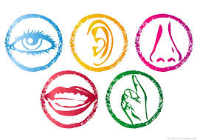  Sensory Detail  Specific descriptive words telling how something looks, smells, tastes, feels, or sounds.  As she licked her lips, she could taste the brown sugar and butter used to make the caramel.
  Interesting words  Words that stand out as meaningful or impactful in a text.  “If you’d given me a room full of sober Indians, crying and laughing and telling stories, then I would have stayed.” | 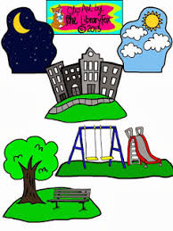  Description  Words that provide specific detail about a character, the setting, an object or event.  Her long brown hair fell over her shoulders and hid her eyes as tears dripped down her face.
  Repetition  When a word or phrase is used multiple times | 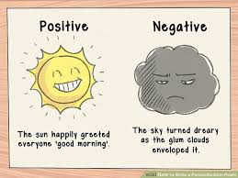  Personification  A figure of speech in which an object or animal is given human feelings, thoughts, or attitudes.  The sun happily greeted everyone ‘good morning’.
  Text features  Parts of a text that add information through a visual element  Charts, graphs, pictures, tables, bold or italicized words, headings |   Metaphor  A comparison without using like or as.  Happiness is the key to success.
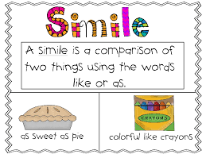  Simile  A comparison using like or as.  She is as sweet as pie. |   Onomatopoeia  Words that tell how something sounds.  “Ring” “Meow”
  Bold beginning  A strong opening that catches attention through the use of words |   Powerful end  A meaningful ending that makes the reader think deeply based on the use of words
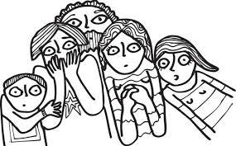  Suspense  Words that create a feeling of excitement to find out what will happen next.  Tarzan’s love, Jane, is carried away by a giant ape. Jane asks “How can anyone get rid of such a mighty villain.” This tells the reader Jane thinks Tarzan will not be able to save her, causing suspense. |   Alliteration  The repetition of initial consonant sounds
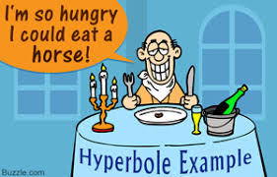  Hyperbole  An extreme exaggeration. | 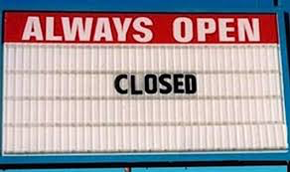  Irony  The expression of meaning using words that normally mean the opposite, usually for humor
  Idiom  A common saying used to express an idea | 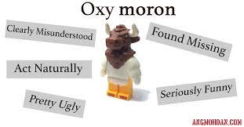  Oxymoron  The pairing of words that hold opposite meaning.
  Statistic  A quantity or number that reveals specific information  “Nearly 18% of Americans eat fish daily.” | 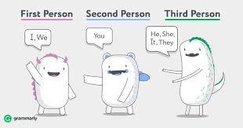  Point of view  The point from which a story is viewed  The way a character feels determined through thoughts, actions, and words.
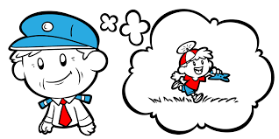  Flashback  The description of an event that took place earlier than the rest of the story.  I remembered when it all started. Our house was nothing but a series of screaming then weeping, over and over again. | 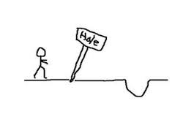  Foreshadowing  Hints provided to assist readers in predicting what will happen next.  He said if anyone ever beat him again, he’d kill them.

